PCA America CAP Month ‘25
Co-branded Assets
Social Media Campaign

Here is the link to the graphic assets: PCAA CoBrand Social Media - Dropbox

DATE | POST | GRAPHIC ASSET | POST COPY
MON  03/31 | CAP Month  Kick-off |  | April is Child Abuse Prevention Month!  This month is dedicated to raising awareness and preventing child abuse and neglect. At Prevent Child Abuse America, we believe in creating a world where all children grow up happy, healthy, and prepared to succeed. Throughout April, expect enlightening posts about prevention strategies, community partnerships, and how you can get involved. But we need your help to make a difference. Consider donating to support our ongoing efforts and join us in wearing blue to show your commitment to preventing child abuse. Together, let’s build a hopeful future for every child because every child deserves a loving and nurturing childhood.  #CAPMonth2025 #PoweredByHope #PCAAmerica
TUES  04/01 | Announce Wear Blue Day |  | Why do we wear blue?  It's more than a color; it's a symbol of our fight against child abuse. Hear from our community why they'll wear blue on April 4th. Share your story in the comments!  #WearBlueDay2025  #CAPMonth2025 #PoweredByHope #PCAAmerica
WED  04/02 | What is Primary Prevention? |  | Primary prevention focuses on stopping child abuse and neglect before it starts, fostering strong communities and supportive families to help all children thrive. Together, we can create lasting change!  #CAPMonth2025 #PoweredByHope #PCAAmerica
THURS  04/03 | Wear Blue  Reminder | 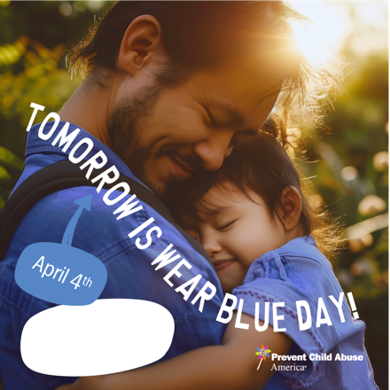 | Tomorrow is Wear Blue Day, and we want YOU to join the movement! On this day, let's come together to raise awareness and show our commitment to preventing child abuse. Wear your blue and help spread the message of hope for every child’s bright future.  Take a picture of yourself rocking your blue and share it with us! Don't forget to tag @PCAAmerica and use the hashtag #CAPMonth2025. Together, we can create a ripple effect of awareness and action!  Let's turn the world blue in honor of every child who deserves to grow up in a safe, loving environment. Ready to join us? Let’s make this Wear Blue Day one to remember!  #WearBlueDay2025 #CAPMonth2025 #PoweredByHope #PCAAmerica
FRI  04/04 | Partners in Prevention | 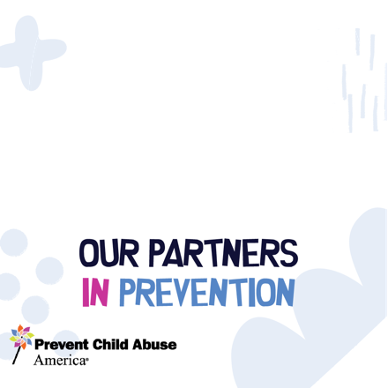 | Together, we can make a real difference. Our partnerships with local and national organizations help us strengthen our impact in communities across the country. Let’s continue to work together for a safer future for children everywhere.  #CAPMonth2025 #PoweredByHope #PCAAmerica
WED  04/09 | Primary  Prevention  Ecosystem | 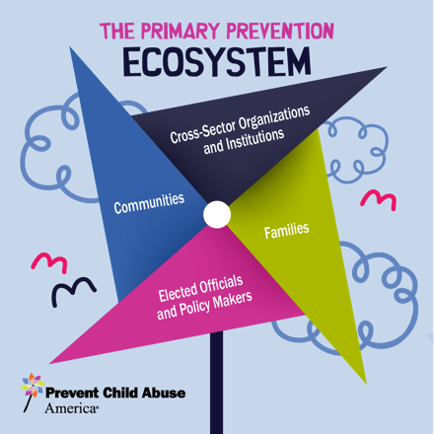 | A strong prevention ecosystem brings together families, communities, policymakers, and organizations at every level to create lasting change. Together, we can build a world where every child is safe and supported.  Learn more: [Link]  #CAPMonth2025 #PoweredByHope #PCAAmerica
THURS  04/10 | What Does the Pinwheel Mean? | 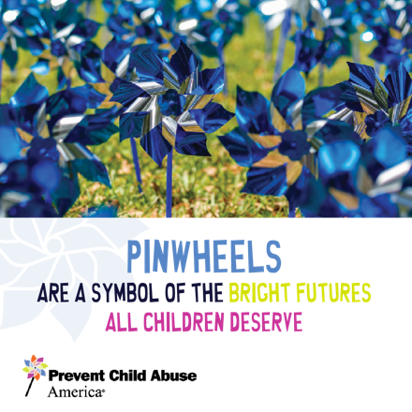 | The pinwheel is the symbol of child abuse prevention, reminding us of the bright futures every child deserves. Color your own pinwheel and share it with us to spread the message of hope!  #CAPMonth2025 #PoweredByHope  #PCAAmerica
FRI  04/11 | Invite People to Share | 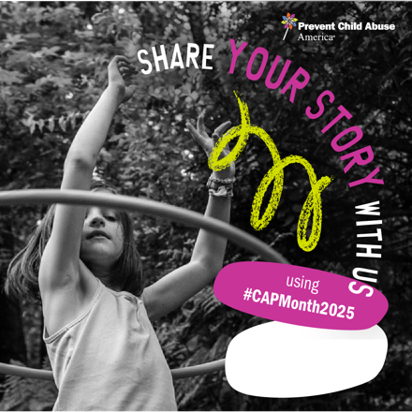 | Parents, your wisdom and experiences matter. Share your story with us and inspire others to keep going. Whether it's a moment of triumph or a challenge, your journey is valuable and can help build a community of support.  #CAPMonth2025 #PoweredByHope  #PCAAmerica
SUN  04/13 | State / Local Resource |   Pick from various templates and “stickers” in graphic assets | Find out how local resources can help families and children in your community thrive. We are here to support families with the tools and information they need to succeed.  #CAPMonth2025 #PoweredByHope  #PCAAmerica
MON  04/14 | Did You Know? |  | Innovative policies like Paid Family Leave (PFL) are driving progress by empowering caregivers and promoting healthier family dynamics. Robust Paid Family Leave (PFL) policies lead to:  - Improved Mental Health: Lower stress and reduced use of alcohol or drugs as coping mechanisms.  - Enhanced Family Well-being: Better coping skills for parents, improving overall family stability  - Increased Economic Stability: Greater access to community services and financial support.  - Better Child Outcomes: Enhanced health and development, including higher rates of well-child visits and fewer children requiring special education.  Strong policies = Stronger families.  Learn more about our research findings CDC Research Project - PFL and ECEC Policies  #CAPMonth2025  #PoweredByHope  #PCAAmerica
 | Tomorrow is DAD | 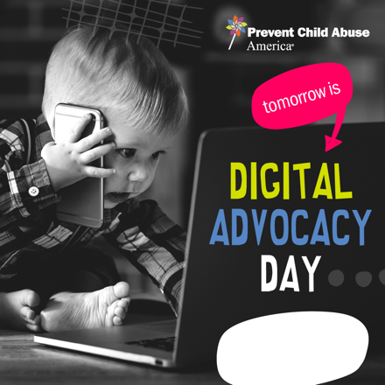 | Raise your voice on April 16 for our nationwide Digital Advocacy Day! Advocate for essential investments in child abuse prevention by contacting your Congress member. Together, we can implement community-based solutions to protect our children.  #CAPMonth2025 #PoweredByHope  #PCAAmerica
WED  04/16 | Digital  Advocacy Day | 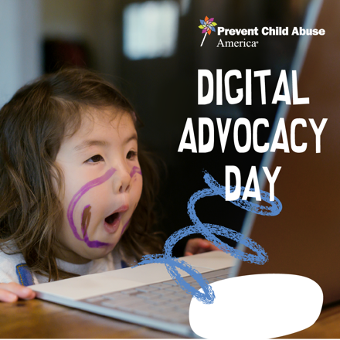  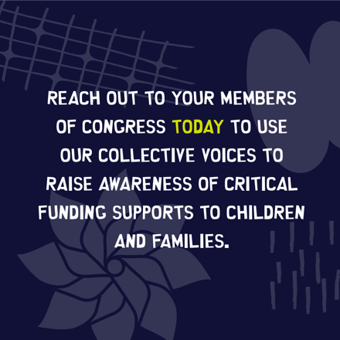  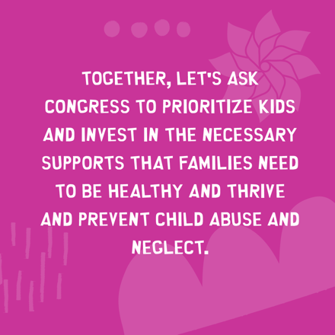  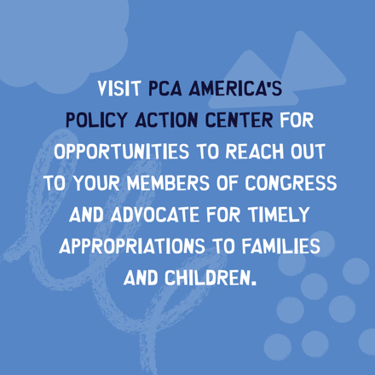 | Today is Digital Advocacy Day!  Raise your voice for child abuse prevention and let’s ask our lawmakers to invest in the well-being of children and families across the country.  #CAPMonth2025 #PoweredByHope #PCAAmerica
THURS  04/17 | Prevention's Impact | 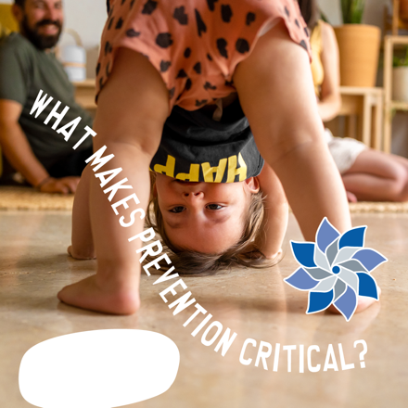 | Prevention is powerful. By addressing the root causes of child abuse, we can protect children and build strong, supportive communities that uplift families.  #CAPMonth2025 #PoweredByHope  #PCAAmerica
 | Partners in Prevention | 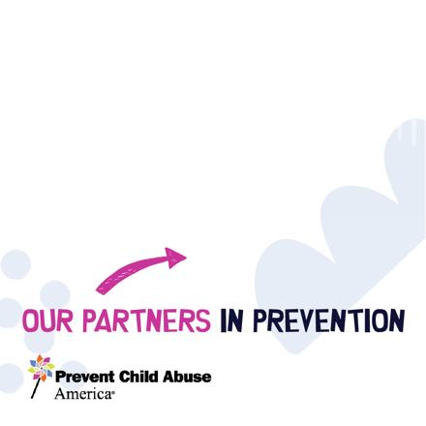    Several templates are available in the graphic assets | TBD: Copy in development  #CAPMonth2025 #PoweredByHope #PCAAmerica
MON  04/21 | Did You Know? | 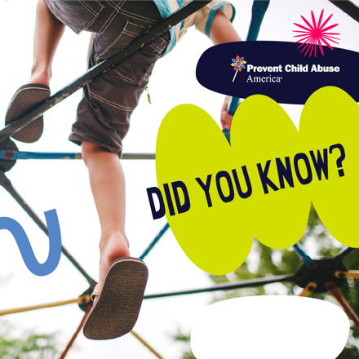 | Did you know that community-based prevention programs can reduce child abuse by up to 20%? Let’s work together to increase funding for these essential services.  #CAPMonth2025  #PoweredByHope  #PCAAmerica
 | Positive Childhood Experiences | 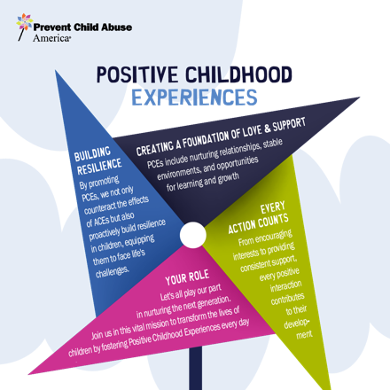 | Positive experiences early in life are key to a child’s development. Let’s help every child have the opportunity to build positive childhood experiences that last a lifetime.  #CAPMonth2025 #PoweredByHope  #PCAAmerica
WED  04/23 | Friday is  a Day of Giving | 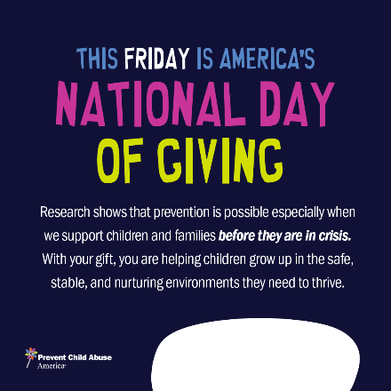 | Friday is America's National Day of Giving  Join us in making a difference! We will unite with our state chapters nationwide to amplify our goal of creating brighter futures for kids through our proven work in child abuse prevention.  Every donation helps us provide crucial support to children and families.  Donate to PCA America or find a local chapter near you to make a donation on Friday, April 25.  Donate: LINK  Find a Chapter: LINK  #NationalDayOfGiving #MakeADifference  #CAPMonth2025  #PoweredByHope #PCAAmerica
THURS  04/24 | Engaging Fathers  in Prevention |  | Fathers and male caregivers play an important role in child abuse prevention. Today, we celebrate their efforts and encourage more involvement in keeping children safe.  #HeroesInFatherhood  #CAPMonth2025  #PoweredByHope  #PCAAmerica
 | Tomorrow  is a Day of Giving |  | Are you ready?  Tomorrow is America's National Day of Giving  Donate to PCA America or find a local chapter near you to make a donation TODAY!  Donate: LINK  Find a Chapter: LINK  #NationalDayOfGiving #MakeADifference  #CAPMonth2025  #PoweredByHope  #PCAAmerica
FRI  04/25 | Day of Giving |  | Today is National Day of Giving! Join us by making a donation to PCA America or a local chapter to help support prevention efforts.  Together, we can make a meaningful difference for children and families.  #NationalDayOfGiving #MakeADifference #CAPMonth2025 #PoweredByHope  #PCAAmerica
SUN  04/27 | State / Local Resource |     Pick from various templates and “stickers” in graphic assets | #CAPMonth2025 #PoweredByHope #PCAAmerica
WED  04/30 | Thank you! |   Follow image above with images shared throughout the month! | A Heartfelt Thanks for an Unforgettable CAP Month  As we bid farewell to April this year, we're overwhelmed with gratitude for your incredible engagement and unwavering dedication. Together, we've transformed Child Abuse Prevention Month into a powerful movement. Your stories, support, and active participation have driven meaningful change and heightened awareness. Let's reflect on our collective achievements, cherish each milestone, and renew our commitment to this vital cause. The journey doesn't end here— it gains momentum. Join us as we continue to strive for a safer tomorrow for every child.  #CAPMonth2025 #PoweredByHope #PCAAmerica

